General Aviation Joint Steering Committee
Loss of Control Working Group

Presentation Notes
Stabilized Approaches and Landings
2020/04-13-187(I)PP

This outreach guidance is provided to all FAA and aviation industry groups that are participating in outreach efforts sponsored by the General Aviation Joint Steering Committee (GAJSC). It is important that all outreach on a given topic is coordinated and is free of conflicts. Therefore, all outreach products should be in alignment with the outline and concepts listed below for this topic.

Outreach Month: July 2021

Topic: Stabilized Approaches and Landings
The FAA and industry will conduct a public education campaign emphasizing the need for training and currency of stabilized approaches.

Background:

A stabilized approach is a key feature to a safe approach and landing. Operators are encouraged by the FAA and the International Civil Aviation Organization (ICAO) to use the stabilized approach concept to help eliminate CFIT. The stabilized approach concept is characterized by maintaining a stable approach speed, descent rate, vertical flightpath, and configuration to the landing touchdown point. Depart the FAF configured for landing and on the proper approach speed, power setting, and flightpath before descending below the minimum stabilized approach height; e.g., 1,000 feet above the airport elevation and at a rate of descent no greater than 1,000 feet per minute (fpm), unless specifically briefed. (Refer to AC120-71.)

Teaching Points:
- Pilots of all certificate levels are prone to destabilized approach and landing accidents.
- Most General Aviation approach and landing accidents occur during the day and half occur in VMC.
- Pilots must accurately assess the risk associated with each flight and plan accordingly. They must also continuously reassess risk en route and commit to alternate plans before they are in a state of emergency.

IMPORTANT – Once you have completed outreach on this topic, please help us track the outreach you have done by entering a PTRS record.

Abstract: Lasting 35 to 45 Minutes, this presentation acquaints the audience with the hazards of fliying unstabilized approaches and landings and suggestions for avoiding accidents.

Format: Information Briefing – Power Point presentation

Required Personnel: FAASTeam Program Manager or designated FAASTeam Rep(s)

Optional Personnel: Flight Instructor, Designees or others who can speak on CFIT

AFS 850 Support: In addition to this document, a Power Point presentation that supports the program is provided. FPMs and presenters are encouraged to customize this presentation to reflect each individual program.

Slides | Script
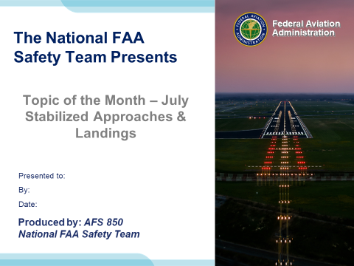 | Slide 1  2020/04-13-187(I)PP Original Author: Jay M Flowers; POC Kevin Clover, AFS-850 Operations Lead, Office 562-888-2020  Presentation Note: This is the title slide for Stabilized Approaches & Landings.  - Script - We have included a script of suggested dialog with most slides. The script will always appear in a non-italic font. Presenters may read the script or modify it to suit their own presentation style. See template slides 5 and 6 for examples of a slides with script.  - Presentation Instructions - (stage direction and presentation suggestions) will be preceded by a Bold header: the instructions themselves will be in Italic fonts. See slides 2, for an example of slides with Presentation Instructions only.  - Program control instructions - will be in bold fonts and look like this: (Click) for building information within a slide; or this: (Next Slide) for slide advance.  - Background information - Some slides may contain background information that supports the concepts presented in the program.  Background information will always appear last and will be preceded by a bold Background: identification.  The production team hope you and your audience will enjoy the show. Break a leg!  (Next Slide)
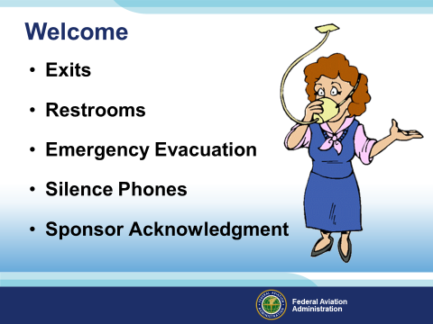 | Slide 2  Presentation Note: Here’s where you can discuss venue logistics, acknowledge sponsors, and deliver other information you want your audience to know in the beginning.  You can add slides after this one to fit your situation.  (Next Slide)
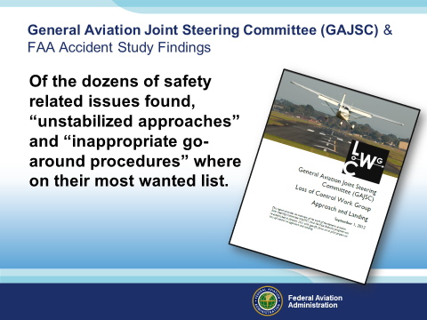 | Slide 3  Of the dozens of safety related issues found, “unstabilized approaches” and “inappropriate go-around procedures” where on their most wanted list.  Definition: A stabilized approach is one in which the pilot establishes and maintains a constant angle glidepath towards a predetermined point on the landing runway. It is based on the pilot's judgment of certain visual clues, and depends on the maintenance of a constant final descent airspeed and configuration.  Presentation Note: GAJSC’s safety enhancement includes updating material to include emphasis on stabilized approaches throughout various scenarios: wind, balked landings, and go-arounds.  (Next Slide)
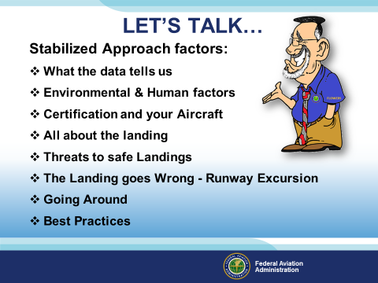 | Slide 4  Here’s what we’re going to discuss today:  - What the accident data tells us  - Environmental & Human factors  - Certification and your Aircraft  - All about the landing  - Threats to safe Landings  - When the landing goes wrong - Runway Excursion  - Going Around  - Best Practices  (Next Slide)
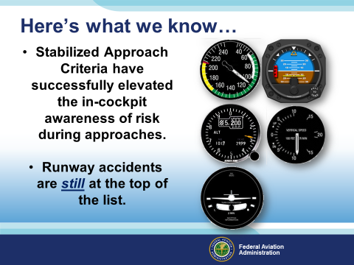 | Slide 5  Stabilized Approach Criteria have successfully elevated the in-cockpit awareness of risk during approaches. We will investigate the threats to a safe landing and present you the necessary strategies to prevent one possible end result - a runway excursion.  (Next Slide)
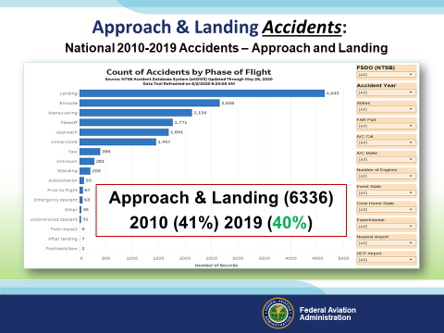 | Slide 6  As you can see by the National data there were a total of 6336 Accidents in the Approach and Landing Phase of flight, The top accident phase of flight for the last 9 years was “Landings” with Approach in the top five. The Accident rate phase of flight percentages remain close with (40%) in 2019, which is down 1% from 9 years before. Although there were fewer accidents in 2019, the type of accidents remains a concern.  Presentation Note: If you would like, update this slide with the most current National FATDAT data. Include any local area data to compare how your local area sizes up to the findings. For purposes of this task, No filters have been applied to the FATDAT. Go to the “Count of Accidents by Phase of Flight” and review the data. You may select specific years to find percentages as seen here.  Since the main topic is on Landings and Approaches to a Landing those categories are your primary concern. As you see in this slide, Landing and Approaches were the primary concern factors for this data slide. Factors such as “Null” may include additional data but require further research by the FPM.  Review your local phase of flight accidents and compare them to the National statistics.  (Next Slide)
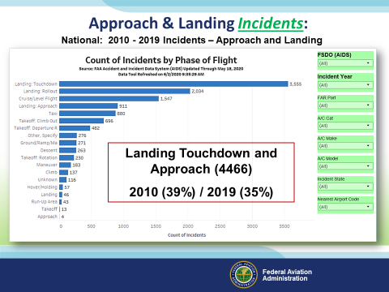 | Slide 7  Touchdown is in the top incident spot with Landing Approach coming in forth.  An average of 37% of all the Incidents involve some facet of unstabilized approaches to landing.  In any case, the local environment can play a part in these causal factors. Topography that leads to visual illusions or an absence of visual cues can be a leading cause in your area.  Presenter: Your additional investigation into the local area may be worthwhile if it reveals a community of pilots that have more than their share of Accidents & Incidents attributable to unstable approaches.  Presentation Note: If you would like, update this slide with the most current National FATDAT data. Include any local area data to compare how your local area sizes up to the findings. For purposes of this task, No filters have been applied to the FATDAT. Go to the “Count of Incidents by Phase of Flight” and review the data. You may select specific years to find percentages as seen here.  Since the main topic is Landing Touchdown and Landing Approach those categories are your primary concern. As you see in this slide, Landing Touchdown was the primary concern factor for this data slide. Factors such as “Null” may include additional data but require further research by the FPM.  Review your local phase of flight accidents and compare them to the National statistics.  (Next Slide)
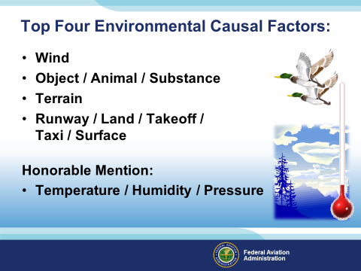 | Slide 8  The top four environmental causal factors are as follows:  Wind – Will the winds aloft in combination with terrain and temperature allow for a stabilized approach?  Object / Animal / Substance – If a critter is reported on the runway, how will that affect your ability to keep the aircraft stable and under control to the surface? (maybe you are to busy looking for the critter?)  If you are approaching in rain, ice, or snow, how will that affect your ability to maintain a stable approach? (Maybe you are spending too much time looking for the runway, distractions come in all forms) In some cases power and airspeed may have to be higher than normal to maintain operational equipment limits such as used for anti-icing or deicing larger aircraft. (Flaps may be limited during icing operations, have you practiced partial flap landings lately? What does the performance chart say?).  Terrain – Sloping terrain, runway slope, updrafts and downdrafts caused by terrain, and sloping visual ques may affect your “out the window” stability of an approach  Runway / Land / Takeoff / Taxi / Surface – distractions such as ability or inability to go-around or where you are going once you get on the ground can all affect your state of mind during your approach.  Honorable Mention:  Temperature / Humidity / Pressure – Distraction involving concern over “once I get in there, can I get back out?”(Mountainous terrain).  Presentation note: If having the most current data is your thing, open the FATDAT, determine the top four environmental factors in your area for this slide.  (Next Slide)
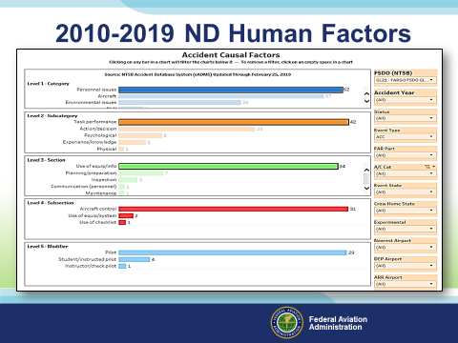 | Slide 9  Presenter: Based on the data from previous slides.  As you can see here, the top human factor found is “personnel Issues” which basically means the pilot or a human element was at fault or affected the outcome.  The subcategories breaking this all down are as follows:  - Task Performance / Action or decision / Psychological  - Use of equipment / Planning or preparation  - Aircraft Control /  - Pilot  (Next Slide)
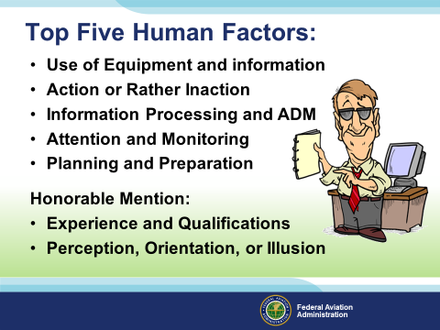 | Slide 10  And the top five Humans Factors are:  - Use of Equipment and information – Familiarity with the aircraft, aircraft systems, or flight characteristics.  - Action – Failed to act or react to the situation / “Never seen this before”  - Information Processing and ADM – Poor recognition skills or lack of ADM  - Attention and Monitoring – Wasn’t paying attention / distracted.  - Planning and Preparation – Didn’t look, forgot, didn’t know.  Honorable Mention:  - Experience and Qualifications – Didn’t know or have experienced the situation before.  - Perception, Orientation, or Illusion – Thought but did not know  All can be controlled or managed through additional Flight Instruction.  (Next Slide)
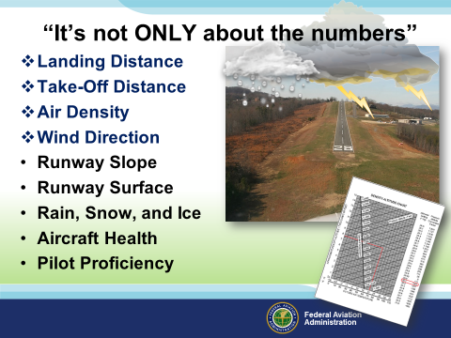 | Slide 11  Going down the list, how many of these do you consider on every flight?  Most pilots only consider the first four.  - Landing Distance  - Take-Off Distance  - Air Density  - Wind Direction  The others seem to be the forgotten hopefuls that most have NO idea what we are talking about, or rather have never taken the time to truly understand:  - Runway Slope  - Runway Surface  - Rain, Snow, and Ice  - Aircraft Health  - Pilot Proficiency  Generally, these forgotten few are only used by the commercial facet of aviation, right?  Do they really affect your aircraft?  The fact of the matter is that the FAA have an expectation performance which is covered in the FARs. Although book numbers are for the day they do not have to be exact to allow for a safe landing or takeoff. For instance:  - If you take your aircraft, at gross weight  - Calculate the hottest day you may operate, say 95 degrees – if the temp is cooler, aircraft will perform better  - No wind – more wind, more lift, better  - No slope on the runway – This will be the only variable that will lead you back to the charts to confirm  - Dry surface – Best case, worst case would be a wet or snow covered runway  - Highest Altitude runway you plan to use – Lower the elevation the better the performance  Calculate the take off distance and add 20 percent to your finding. Use that number as your Go-No Go” for flight planning. The same can be done in cold climate but why. We have already taken the worst case and calculated what is needed to remain safe.  The same can be used for landing calculations. Remember, ‘Reasonable expectation of performance”.  (Next Slide)
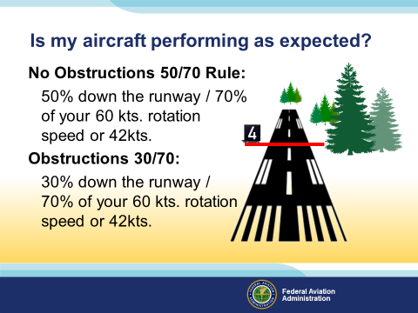 | Slide 12  Is my aircraft performing as expected?  There is a way to figure this out:  No Obstructions 50/70 Rule:  50% down the runway / 70% of your 60 kts. rotation speed or 42kts.  Obstructions 30/70:  30% down the runway / 70% of your 60 kts. rotation speed or 42kts.  (Next Slide)
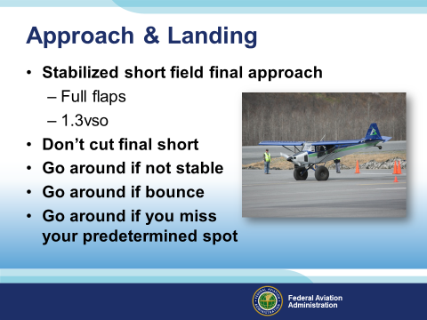 | Slide 13  You’ll want to be stabilized on final approach with full flaps at 1.3 times the stalling speed in landing configuration.  Don’t cut your final short. Make it long enough to be stabile and go around if you’re unstable.  The photo on this slide are of an annual takeoff and landing competition held in Valdez, Alaska. The video demonstrates the capabilities of both plane and pilot to land in highly volatile locations. We strongly suggest you don’t try this at home without some quality instruction.  Let’s look at the certification process to find out more.  (Next Slide)
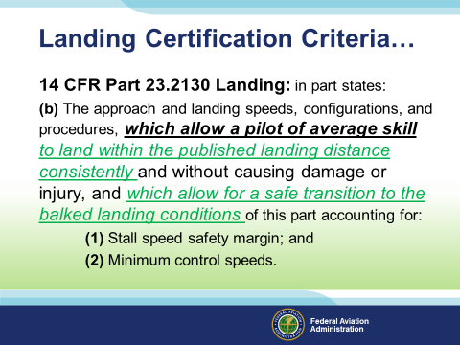 | Slide 14  Preflight planning includes looking at your aircraft performance requirements for take-off and landing. In order to understand the result of your data input, we must first consider the foundational expectation of the data we depend on.  (Click)  14 CFR Part 23.2130 Landing in part states:  (b) The approach and landing speeds, configurations, and procedures, which allow a pilot of average skill to land within the published landing distance consistently and without causing damage or injury, and which allow for a safe transition to the balked landing conditions of this part accounting for:  (1) Stall speed safety margin; and  (2) Minimum control speeds.  (Next Slide)
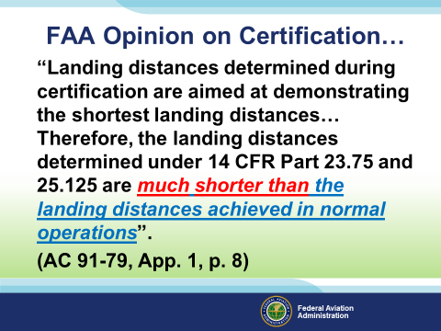 | Slide 15  Here’s what most of you do not know about the certification process…  (Click)  “Landing distances determined during certification are aimed at demonstrating the shortest landing distances… Therefore, the landing distances determined under 14 CFR Part 23.75 and 25.125 are much shorter than the landing distances achieved in normal operations”.  (AC 91-79, App. 1, p. 8)  What we should be asking ourselves is what is the real performance capability of “My” aircraft?  One of the topics we have covered over the years has to do with performance factors, yours and the aircrafts! Challenge yourself and your CFI by paying attention to how your aircraft truly performs.  Make notes, compare with the performance charts in the AFM…yes, that manual located in the seat back next to you…!  (Next Slide)
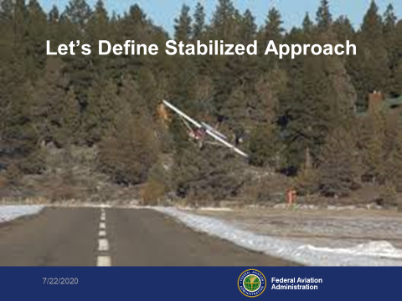 | Slide 16  Now that we’ve defined the issue and how the FAA looks at certification, let’s define what a stabilized approach is.  A stabilized approach is one in which the pilot establishes and maintains a constant angle glidepath towards a predetermined point on the landing runway. It is based on the pilot's judgment of certain visual clues, and depends on the maintenance of a constant final descent airspeed and configuration.  (Next Slide)
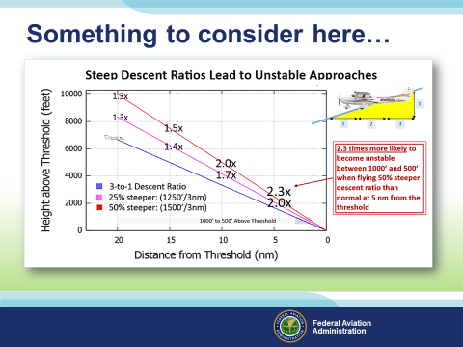 | Slide 17  For some of you, descent to a landing is not even a thought until you are within a few short miles of the airport.  The data in this depiction shows the optimum glide slope of 3 to 1 (3:1) as a blue line. As you can see, glide slopes 1.3x and 1.5x steeper than normal call for greater rates of descent and it is noted that aircraft with these profiles have a higher risk of being unstable. For purposes, the data was presented at 20nm, 15nm, 10nm, and 5nm from the point of touchdown. With a 3:1 glide slope, you have a 50/50 chance of being stable when reaching 500 to 1,000 HAT. Why 50/50? This is because your descent ratio is only one of many factors (such as aircraft configuration) that determine whether your approach will be stable or not. (Next Slide)
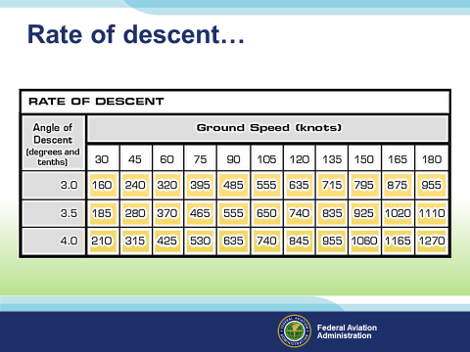 | Slide 18  Rate charts like the one you see here can be found in chart supplements or on the web.  Note: Give the attendees some time to look at the various numbers within the table. Give them a common example such as 3.0 glide Slope (standard for most runways).  3.0 degree GS at 90 knots should give you a 485’/minute descent to the runway. If you challenge yourself to making these numbers work you will eventually figure out what your aircraft needs to make it work.  (Next Slide)
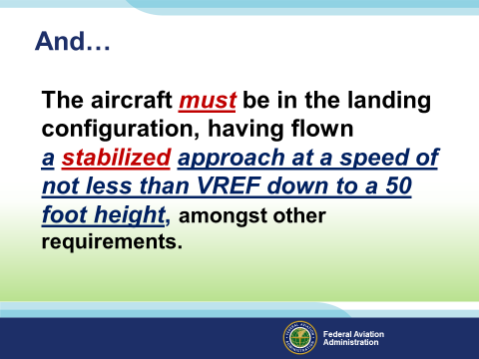 | Slide 19  As stated here:  The aircraft must be in the landing configuration, having flown a stabilized approach at a  speed of not less than VREF down to a 50 foot height, amongst other requirements.  Keep in mind that the numbers as we sometimes call them are only as good as the pilot that truly uses them and understands what it takes to obtain the same final outcome as the manufacturer implies.  (Next Slide)
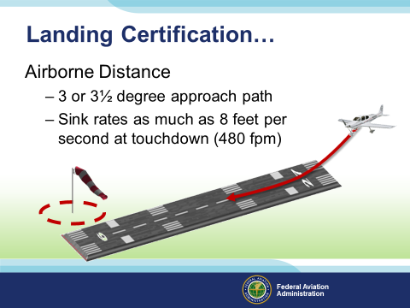 | Slide 20  Airborne Distance  - 3 or 3½ degree approach path  - Sink rates as much as 8 feet per second at touchdown (480 fpm)  As you can see, a 3 – 3.5 degree glideslope is part of certification criteria.  (Next Slide)
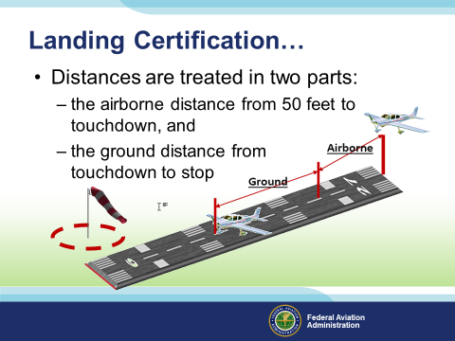 | Slide 21  Distances are treated in two parts:  - the airborne distance from 50 feet to touchdown, and  - the ground distance from touchdown to stop  Actual Landing distances will differ but here is the basic certification expected process. It is like landing the aircraft three times, take the average and viola! …maybe take the longest and use that would be better.  (Next Slide)
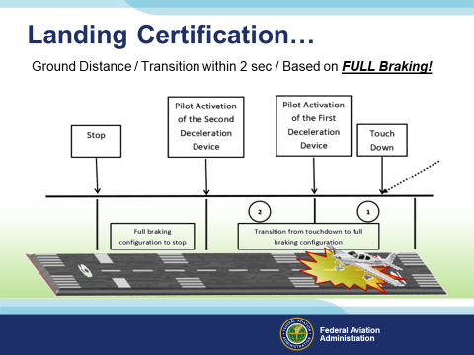 | Slide 22  Ground Distance, transition within 2 sec, and all based on FULL Braking!  Note: Criteria for the certification of Part 23 Aircraft can be found in AC23-19A.  (Next Slide)
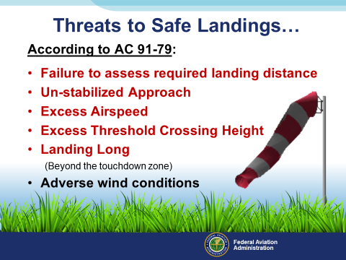 | Slide 23  According to AC 91-79:  - Failure to assess required landing distance  - Un-stabilized Approach  - Excess Airspeed  - Excess Threshold Crossing Height  - Landing Long  (Beyond the touchdown zone)  - Adverse wind conditions  Per our advice and knowledge regarding safe landings, this AC outlines what you should be considering during ALL runway operations.  (Next Slide)
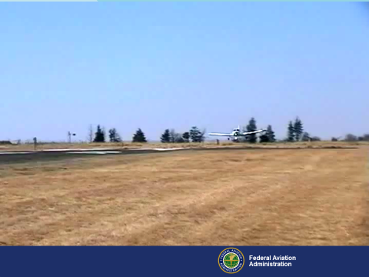 | Slide 24  I think one video is worth a thousand word. (Play the video)  (Next Slide)
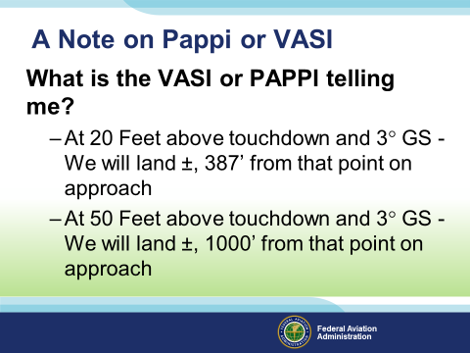 | Slide 25  What is the VASI or PAPPI telling me?  At 20 Feet above touchdown and 3° GS - We will land ±, 387’ from that point on approach  At 50 Feet above touchdown and 3° GS - We will land ±, 1000’ from that point on approach  (Next Slide)
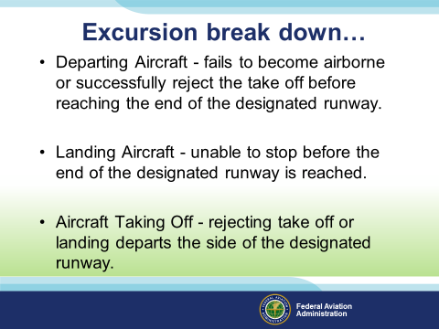 | Slide 26  Departing Aircraft - fails to become airborne or successfully reject the take off before reaching the end of the designated runway.  Landing Aircraft - unable to stop before the end of the designated runway is reached.  Aircraft Taking Off - rejecting take off or landing departs the side of the designated runway.  A runway excursion occurs when an aircraft on a runway surface departs the end or the side of that runway surface.  (Next Slide)
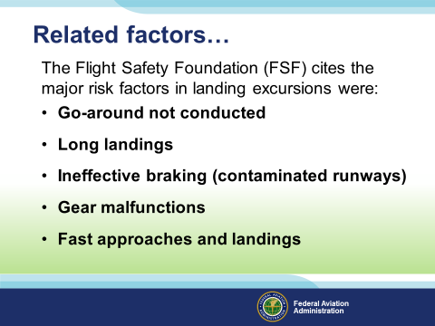 | Slide 27  The Flight Safety Foundation (FSF) cites the major risk factors in landing excursions were:  Go-Around - When is the last time you actually had to GO-AROUND?  Any luck at all says you have not since your flight instructor last pulled that “fuel truck on the runway!” ploy on you 25 years ago. You need to practice if the mind and soul can perform this task without consequence.  Long Landings – 10,000 foot runway…understood but why?  Ineffective braking – Nothing like that icy runway after a 14 day of hard flying!  Gear Malfunctions – “Well it’s been working fine all day…?” When is the last time you actually lowered the gear or ran the process from the Emergency Checklist? Maybe it’s time to dig under all that stuff between the seats and find the Emergency Gear Extension handle hiding under that cover that has the broken Zeus screw in the cover that may require a special tool to open…  Fast Approaches and Landings – landing at twice the VSo airspeed of the aircraft has 4 times more kinetic energy available for you to damage something if you leave the runway. ($KE = 1/2Mass X V2)$  (Next Slide)
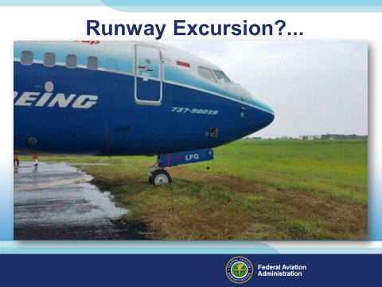 | Slide 28  A runway excursion occurs when an aircraft on a runway surface departs the end or the side of that runway surface. No other aircraft, vehicle, or pedestrian where involved.  Runway excursions can occur on takeoff or landing  - Veer Off – Depart the side of the runway  - Overrun – Depart the end of the runway  Either way your commitment to a take-off or landing needs to be based on data you’ve reviewed and  trained for.  (Next Slide)
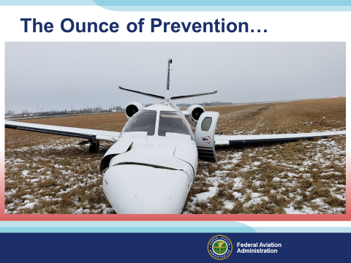 | Slide 29  Just as in this incident/accident, the pilot was undertrained and underqualified to be in this aircraft.  Training and a willingness to comply with the stabilized approach guidelines in this presentation  and the outcome would have been quite different.  Factual Data: Location: Fargo, ND Accident Number: CEN19LA039 Date & Time: 11/30/2018, 1353 CST Registration: N941JM Aircraft: Cessna 550 Injuries: 9 Minor, 2 None Flight Conducted Under: Part 91: General Aviation - Business Analysis  The commercial pilot was conducting a cross-country, business flight with 10 passengers onboard the 8- passenger airplane. He reported that air traffic control cleared the flight for an instrument landing system (ILS) approach to the runway. While descending, the airplane entered instrument meteorological conditions (IMC) at 3,100 ft mean sea level (msl), and ice started to accumulate on the wing's leading edges, empennage, and windshield. The pilot activated the pneumatic deice boots multiple times during the approach and slowed the airplane to 120 knots. The airplane then exited the clouds about 400 ft above ground level (agl), and the pilot maintained 120 knots as the airplane flew over the airport fence; all indications for landing were normal. About 100 ft agl, the airplane started to pull right. He applied left correction inputs, but the airplane continued to pull right. He applied engine power to conduct a go-around, but the airplane landed in grass right of the runway, sustaining damage to the wings and landing gear. Witnesses and passengers reported that the airplane stalled.  During examination of the airplane immediately after the accident, about 1/2 to 1 inch of mixed ice was found on the right wing's leading edge, the vertical and horizontal stabilizers, and the angle of attack probe. Ice was also observed on the windshield. The flaps were found in the "up" position. Flight control continuity was established.  Probable Cause The National Transportation Safety Board determines the probable cause(s) of this accident to be: The pilot's failure to lower the flaps during the approach and maintain sufficient airspeed while flying in instrument meteorological and icing conditions and the accumulation of ice on the wings' leading edges, which resulted in the exceedance of the airplane's critical angle of attack and subsequent aerodynamic stall. Contributing to the accident was the pilot's lack of proper qualification to operate the airplane under a single pilot exemption due to his lack of total turbine time, which led to task saturation and his failure to properly configure the flaps for landing.  (Next Slide)
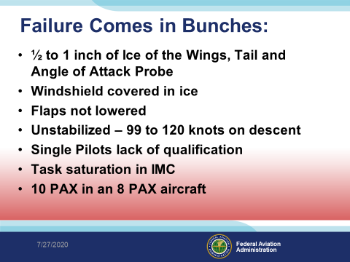 | Slide 30  Failure Comes in Bunches:  - ½ to 1 inch of Ice of the Wings, Tail and Angle of Attack Probe  - Windshield covered in ice  - Flaps not lowered  - Unstabilized – 99 to 120 knots on descent  - Single Pilots lack of qualification  - Task saturation in IMC  - 10 PAX in an 8 PAX aircraft  (Next Slide)
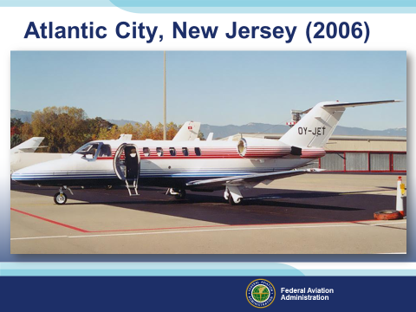 | Slide 31  You may remember this one from the internet. The airman landed his jet downwind on a short runway, overshot the landing and ended up in the lake. All passengers survived and exited to boats in the area. Suddenly one of the engines starts up and goes to full power! The aircraft continued to truck around the bay as the it finally took on enough water to flood the engine and stop it. Here’s the factual on the incident.  The pilot performed "a low pass" over the runway, and then touched down approximately 1,000 feet beyond the approach end of the 2,948-foot long runway (1948 feet remaining), with a tailwind of approximately 10 knots. After touchdown, the airplane continued off the end of the runway, and subsequently impacted water.  According to the Cessna 525A Landing Distance Chart, an airplane with a landing weight of 11,400 pounds required 3,000 feet of landing distance, in a no wind situation. With a 10 knot tailwind, the airplane required 3,570 feet of landing distance. The published airport diagram for the airport, was observed attached to the pilot's control column after the accident. A notation, which read, "airport closed to jet aircraft" was observed on the diagram. Additionally, the same notation, "Arpt CLOSED to jet traffic," was observed in the FAA Airport/Facility Directory. Examination of the airplane revealed no mechanical deficiencies.  Things that make you go Hmmmm?  (Next Slide)
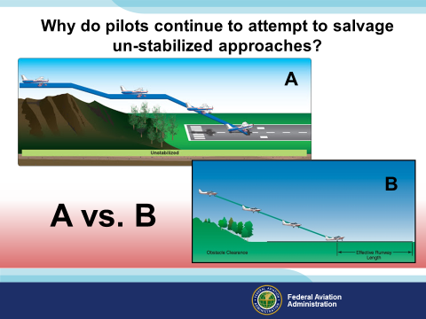 | Slide 32  Why do pilots continue to attempt to salvage un-stabilized approaches?  In the depictions here we have approaches to a runway. “A” is what I’m certain ALL of you have at one time or another done. “B” however is a more stabilized approach concept which just might keep you out of the trees.  (Next Slide)
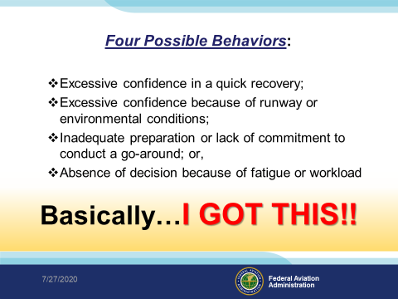 | Slide 33  Many of these accident stories have the term ”I got this” buried deep down in the thoughts of the airman looking at his/her damaged aircraft.  Four Possible Behaviors:  - Excessive confidence in a quick recovery;  - Excessive confidence because of runway or environmental conditions;  - Inadequate preparation or lack of commitment to conduct a go-around; or,  - Absence of decision because of fatigue or workload  (Click)  Basically… “I GOT THIS” (Next Slide)
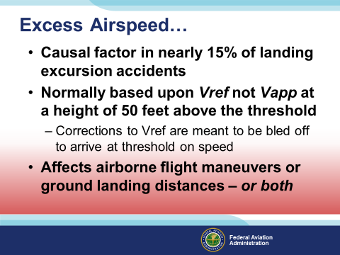 | Slide 34  Excess airspeed is a causal factor in nearly 15% of landing excursion accidents.  - Expected approach speed is normally based upon Vref (1.3 x Vso) not Vapp (1.3 x Vso plus) at a height of 50 feet above the threshold.  Notes: VREF usually is defined as: 1.3 x stall speed with full landing flaps or with selected landing flaps. VAPP or Final approach speed is defined as: VREF + corrections.  - Corrections to Vref are meant to be bled off to arrive over the threshold at VREF or “On Speed”.  - Affects airborne flight maneuvers or ground landing distances – or both.  Under certain circumstances, the equipment on any given aircraft is not designed for a test run at the excessive speeds sometimes thought to be okay to land with. Example, certain models of aircraft require brake system upgrades or specific trunnion upgrades necessary for abnormal runway conditions (gravel, grass, rocks, sand, water, and ice etc.)  (Next Slide)
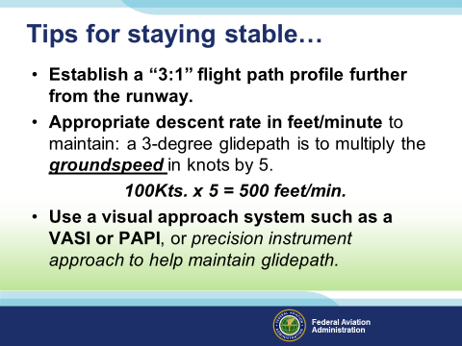 | Slide 35  How many Instrument Rated Pilots do we have here today?  For the IFR community, you will find the center of the glide slope signal is calibrated to define a glide path of approximately 3° above horizontal (ground level). You will also find that in most cases the glide path is can be flown several miles outside of the Final Approach fix.  For VFR pilots, you usually do not start descending for the runway until you are 5 miles or less from the runway. Keep in mind that once you start a descent for landing, the aircraft should be set up and the pilot:  - Establish a “3:1” flight path profile further from the runway, for IFR types, typically the aircraft is stabilized and ready for the approach at least 5 miles from the landing point.  - If in the traffic pattern, appropriate descent rate in feet/minute to maintain: a 3-degree glidepath is to multiply the groundspeed in knots by 5. (100Kts. x 5 = 500 feet/min.) Establishing this glidepath is largely dependent on the aircraft, pilot skill, and knowledge of how the aircraft configurations affect the desired outcome.  - Use a visual approach system such as a VASI or PAPI, or precision instrument approach to help maintain glidepath.  (Next Slide)
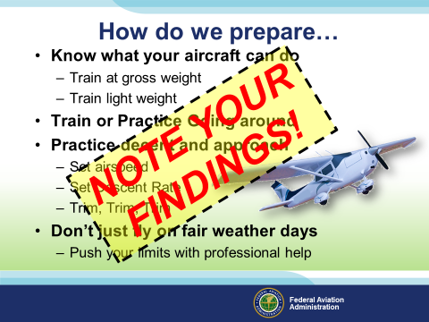 | Slide 36  How do we prepare?  Know what your aircraft can do  - Train at gross weight  - Train light weight  Train or Practice Going around  Practice decent and approach  - Set airspeed  - Set Descent Rate  - Trim, Trim, Trim  Don’t just fly on fair weather days  - Push your limits with professional help  Funny thing about flying, if it has never happened to you…your probably haven’t flown enough!  Pushing yourself to fly by the numbers is the first step towards being proficient.  Take regular flight instruction with challenges in mind. Boldly go where you have never gone before, practice with professional help and planning. Know before you go.  (Click)  Note Your Findings!  (Next Slide)
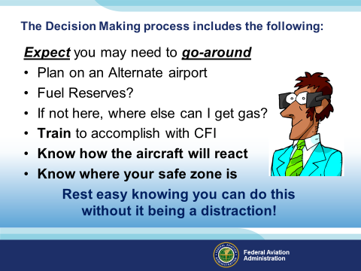 | Slide 37  The Decision Making process includes the following:  Expect you may need to go-around – training is the only way this gets done.  - Plan an Alternate airport – This must be a habit to be part of the plan.  - Plan extra time in the air – Fuel to destination plus :30 or :45 is not enough, you may find yourself holding for a temporary runway issue, unscheduled runway closure or you may need to divert to your alternate landing airport.  - Review services in the event – Part of planning.  - Train to accomplish with CFI – know your limitations.  - Know how the aircraft will react – know the aircrafts limitations.  - Know where your safe zone is - Your safe zone is a place where questions have been answered, risk has been identified, and mitigated to the point that success is basically guaranteed or really close!  Rest easy knowing you can do this without it being a distraction!  (Next Slide)
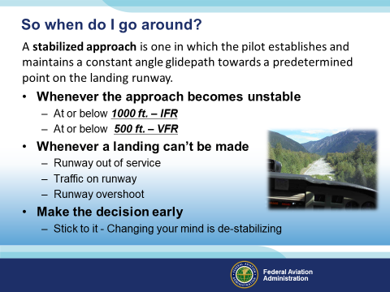 | Slide 38  So when do I go around? (Click)  Remember: A stabilized approach is one in which the pilot establishes and maintains a constant angle glidepath towards a predetermined point on the landing runway.  If you’re at or below 1000 ft. in IFR, or at or below 500 ft. in VFR and the approach is not stabile it’s time to miss the approach or go around.  Likewise if the runway you’re approaching is out of service or there’s traffic on it that won’t be clear when you get there it’s also time to go around. (Click)  Whatever the situation, the earlier you make the go around decision the easier it will be and once you’ve decided to go around; stick to that decision.  Presentation Note: Some pilots maintain 500 feet VFR is too high to be stable. They say at 500 feet they’re still on base – maneuvering to final. My counter has been, “On base are you configured for landing, on course, on airspeed, & on altitude or descending on glide path as appropriate? If so – you’re stabile – if not maybe you should be considering a go-around”. JS  (Next Slide)
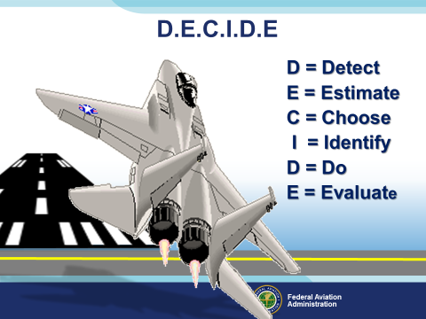 | Slide 39  Let’s review quickly elements of the DECIDE model for decision making:  - Detect a change needing attention  - Estimate the need to counter or react to change  - Choose the most desirable outcome for the flight  - Identify actions to successfully control the change  - Do something to adapt to the change  - Evaluate the effect of the action countering the change  Discussion: Airman and CFIs  Does this sound familiar to you?  At what point in your training, education, or planning should we be using this?  CFIs, How do we reinforce this concept?  Do you provide opportunities for your students to practice using this?  (Next Slide)
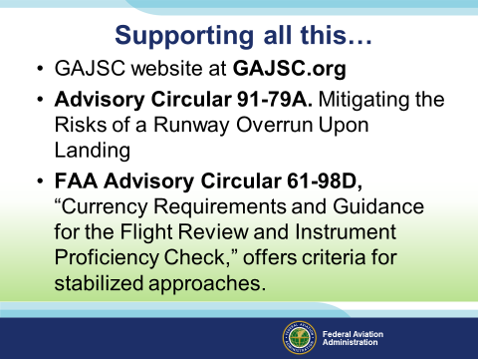 | Slide 40  Support data you may want to look at:  Presenter: give this slide a moment for attendees to snap a picture or write down the necessary data from this slide.  Resources:  - GAJSC website at GAJSC.org  - Advisory Circular 91-79A. Mitigating the Risks of a Runway Overrun Upon Landing  - FAA Advisory Circular 61-98D, “Currency Requirements and Guidance for the Flight Review and Instrument Proficiency Check,” offers criteria for stabilized approaches.  (Next Slide)
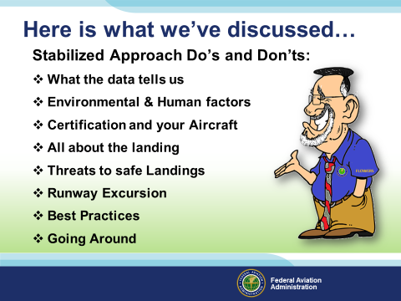 | Slide 41  Here is what we’ve discussed  Stabilized Approach Do’s and Don’ts:  - What the data tells us  - Environmental & Human factors  - Certification and your Aircraft  - All about the landing  - Threats to safe Landings  - Runway Excursion  - Best Practices  - Going Around  (Next Slide)
Slide 42

Faasafety.gov was designed as a foundational platform for assisting pilots in becoming proficient aviators. Join us on our website to find out more about the program.
Local FAASTeam Program Managers and FAASTeam Representatives are available to assist you in getting started with this industry supported program. Sponsoring more than 8000

(Next Slide)
Slide 43

Practice may make you perfect, it will save your life!
Training is credited
WINGS participation can save you money
Insurance Discounts
Less bent metal!

(Next Slide)

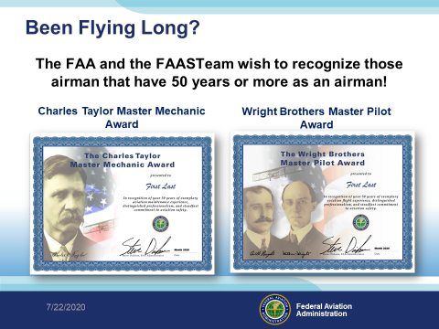 | Slide 44  Been Flying Long?  The FAA and the FAASTeam wish to recognize those airman that have 50 years or more as an airman!  Contact your local FSDO, FAA Safety Team Program Manager, or FAASTeam Representative for information and acceptance criteria. You can also go to our website at faasafety.gov, view and download the application!  (Next Slide)
Slide 45

Now there’s even more reasons to participate in WINGS. Every time you complete a WINGS Phase you’re eligible to win cash the WINGS Sweepstakes.
The sweepstakes is generously funded by Paul Burger, a long time advocate for general aviation safety and a retired aviator who believes participation in this program saves lives. VISIT WWW.MYWINGSINIATIVE.ORG to learn more and enter the sweepstakes.

(Next Slide)
Slide 46

After you’ve completed a phase of WINGS you can enter the sweepstakes by clicking on “Claim Rewards” in the “WINGS – at a glance” section of your My WINGS page and select WINGS Sweepstakes. Or you can go directly to the mywingsinitiative.org website.

(Next Slide)

Slide 47

These awards highlight the important leadership roles these individuals play in promoting aviation safety, education, and professionalism.
Winners are recognized locally, regionally and nationally. National winners are recognized during AirVenture in Oshkosh, WI each July. There, they also receive gifts provided by sponsors and contributors.
Note: Flight Safety is for the FAASTeam Representatives.

(Next Slide)

Slide 48
Note: Update the winners from the GA Awards web site please.

(Next Slide)

Slide 49

Presenter: For each presentation year, update this link by verifying the QR code link.
THIS SLIDE IS REQUIRED AS PART OF ALL FAASTEAM PRESENTATIONS!

(Next Slide)

Slide 50

Presenter: Update this slide for your presentation.

(Next Slide)

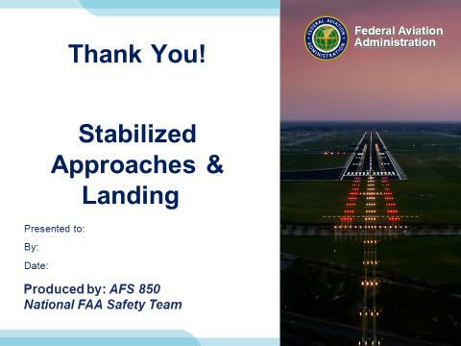 | Slide 51

Appendix I – Equipment and Staging
Equipment:
- Projection Screen & Video Projector suitable for expected audience
  - Remote computer/projector control available at lectern or presenter location
    - In lieu of remote – detail a Rep to computer/projector control.
- Presentation Computer
  - Note: It is strongly suggested that the entire program reside on this computer.
- Back up Projector/Computer/Media as available.
- PA system suitable for expected audience
  - Microphones for Moderator and Panel
    - Optional Microphone (s) for audience
- Lectern (optional)

Staging:
- Arrange the projection screen for maximum visibility from the audience.
- Equip with PA microphones
- Place Lectern to one side of screen. This will be used by presenters and moderator

References:

- Stabilized Approach and Go-around
https://www.faa.gov/news/safety_briefing/2018/media/SE_Topic_18-09.pdf
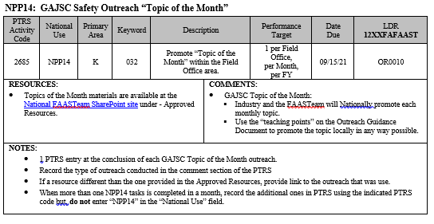
IMPORTANT – Once you have completed outreach on this topic, please help us track the outreach you have done by entering a PTRS record.

